Visit Naples

Visit Naples is a web project offering a guide to Naples through an engaging and interactive platform. The project includes the following sections:

* Home Page: Welcoming visitors with an overview of Naples.
* Gastronomy: Exploring the culinary traditions of the city.
* Sites: Highlighting the most important landmarks and attractions.
* Football: Celebrating Naples’ passion for football, including SSC Napoli club history.
* Meteorology: Providing up-to-date weather information.
* Game: An interactive head or tails game that pays homage to the Federico II University.
* Reservations: Allowing users to book experiences or services.

The project employs a variety of technologies, including HTML, CSS, JavaScript, PHP, XML, DTD, and XSL, to deliver a good experience.

Breadcrumbs are included on every page to enhance navigation

Home Page

The Home Page features an interactive roulette for the main image. This functionality, implemented in index.js, ensures that a randomly selected image is displayed each time the page is loaded, creating better user experience. Additionally, the page includes a registration form, allowing visitors to sign up with ease.

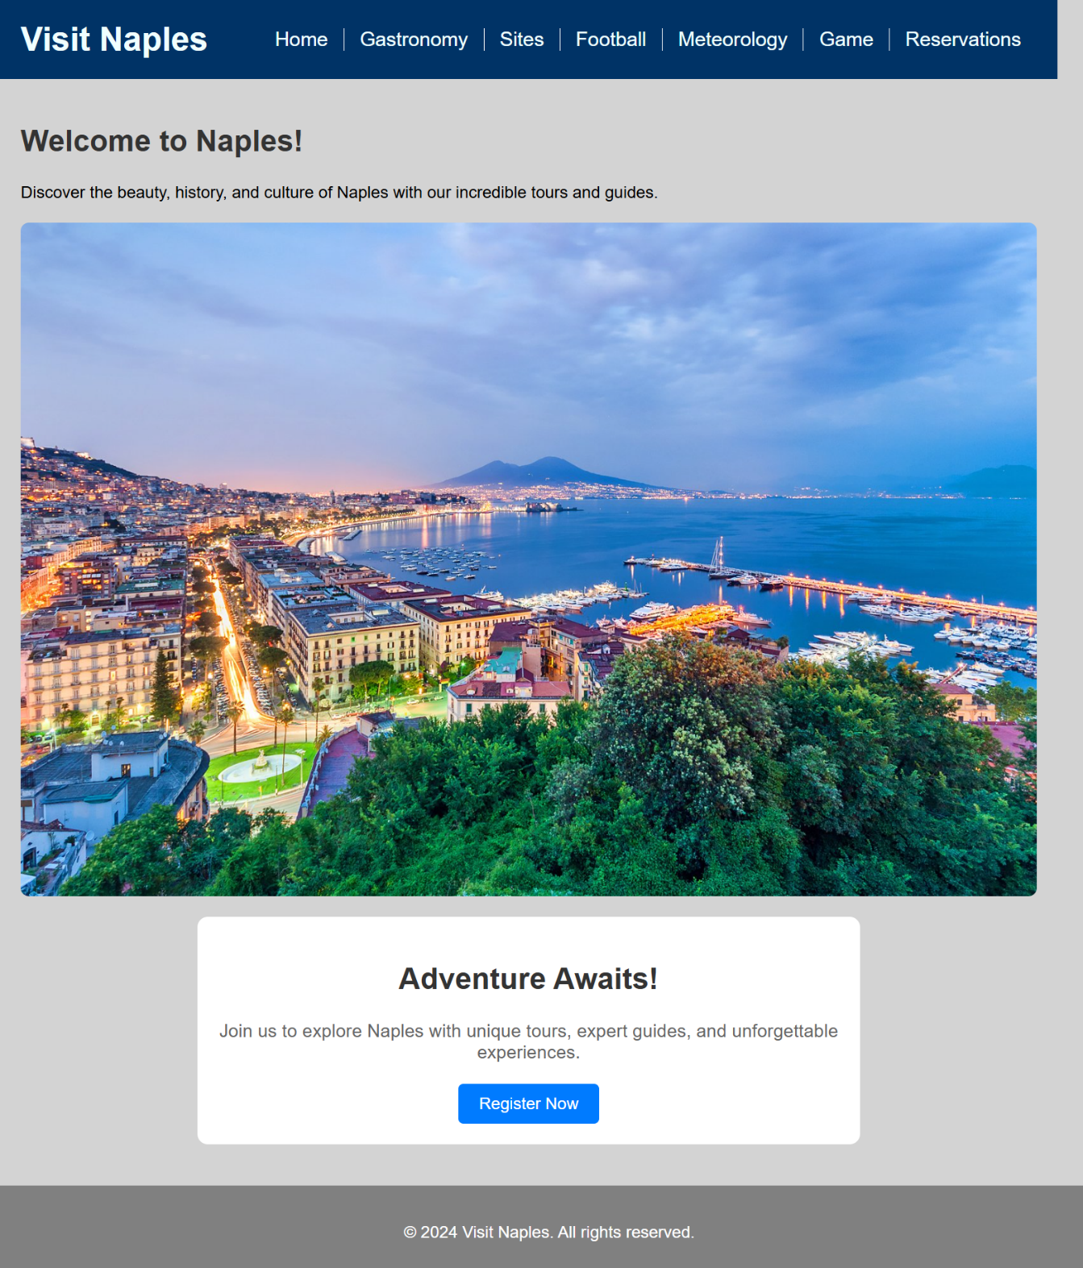

Sites

The Sites Page presents the most iconic landmarks of the city, with the site data structured in XML. The data follows a DTD and the XML data is then transformed into HTML using XSL, which allows it to be displayed in a table format with appropriate styling via CSS.

**Features:**

* **Table:** Displays site names, descriptions, images, and locations.
* **ComboBox:** Below the table, a combo box allows users to select a site. When selected, the photo, position on Google Maps, price and opening hours of the site are displayed for further details.

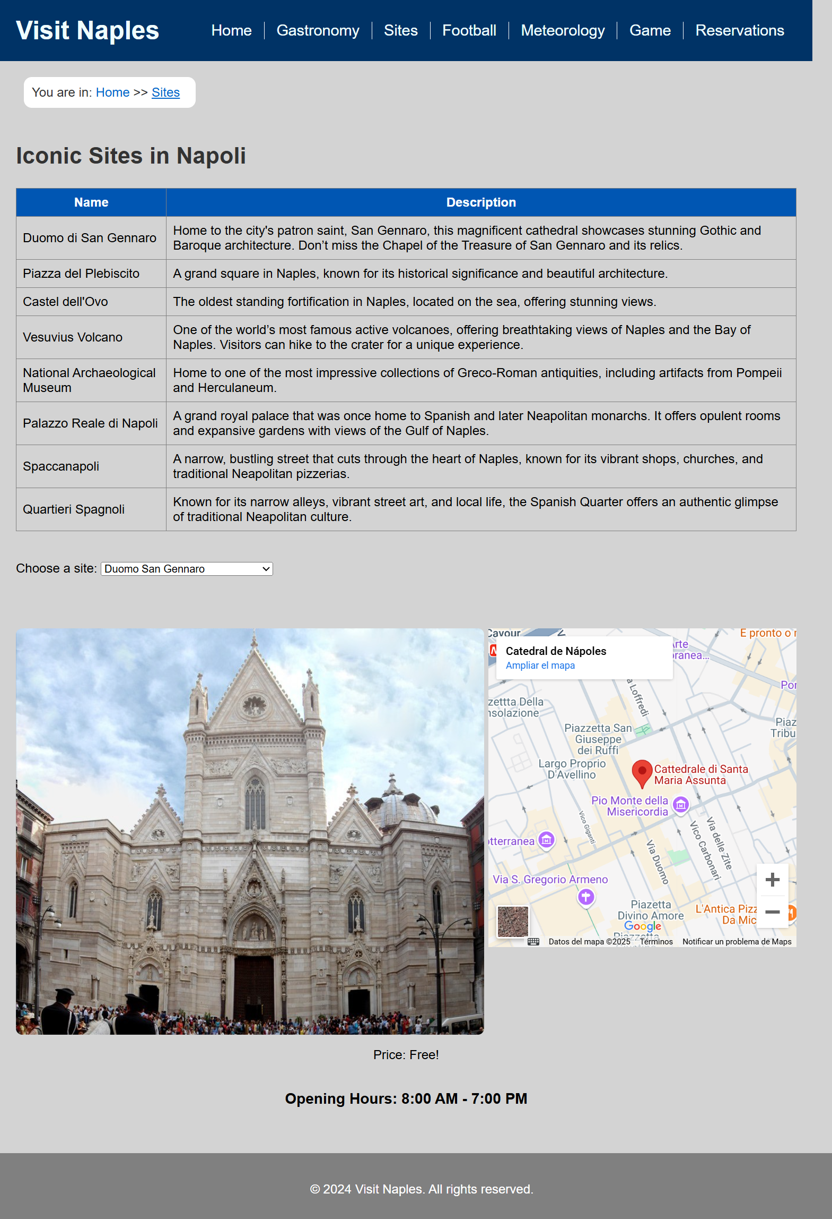

Gastronomy

The Gastronomy Page of Visit Naples showcases some of the most iconic dishes of the city. The page features detailed articles about popular Neapolitan dishes, including Pizza Margherita, Pizza Fritta, Pasta e Patate, Ragù, Parmigiana di Melanzane, and Frittata di Pasta.

Each article includes:

* A description of the **ingredients**.
* A brief **history** of the dish, explaining its origins and significance to Naples and Italian cuisine.
* **Images** of the dishes.

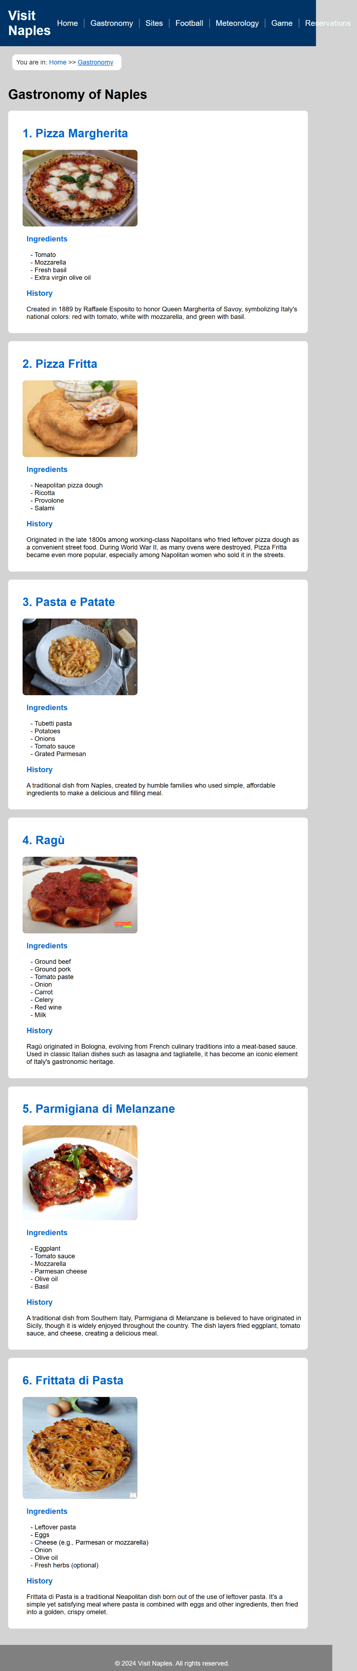

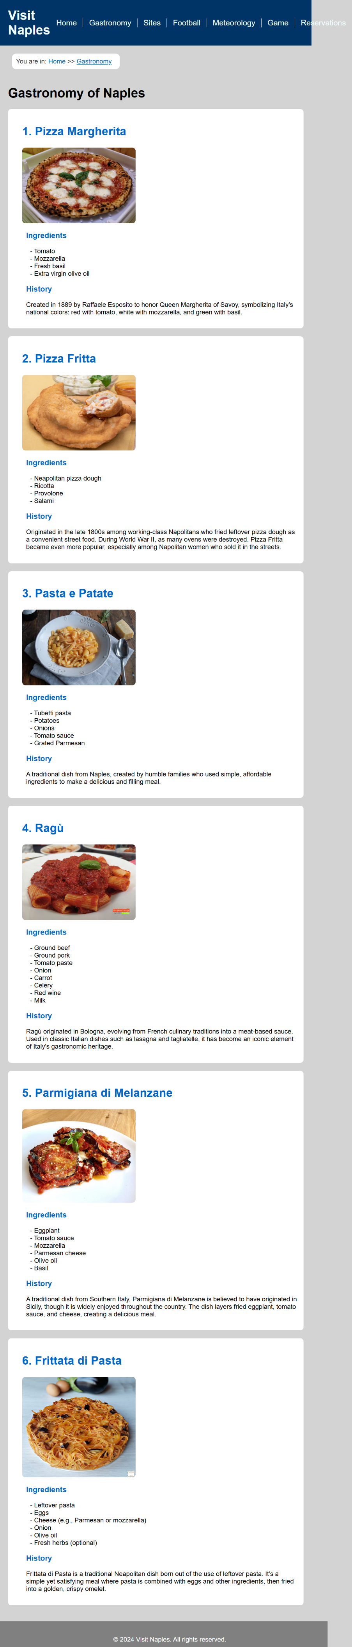

Football

The Football Page of Visit Naples focuses on the city’s beloved football club, SSC Napoli. It covers key aspects such as the club's rich history, its home stadium Stadio Diego Armando Maradona, and a detailed list of the team's trophies and titles.

**Key Features:**

* **SSC Napoli:** A brief history of the club, including its formation in 1926 and its success in Italian football.
* **Stadium Info:** Information about Stadio Diego Armando Maradona, including its renaming in 2020 to honor Diego Maradona.
* **Trophies and Titles:** A table listing the club's major achievements over the years, including Serie A titles, Coppa Italia, and UEFA Cup wins.
* **Recent Achievements:** A section highlighting Napoli's 2022-2023 Serie A title win.
* **Club Anthem:** An audio player for Napoli’s anthem, "O surdato 'nnammurato."

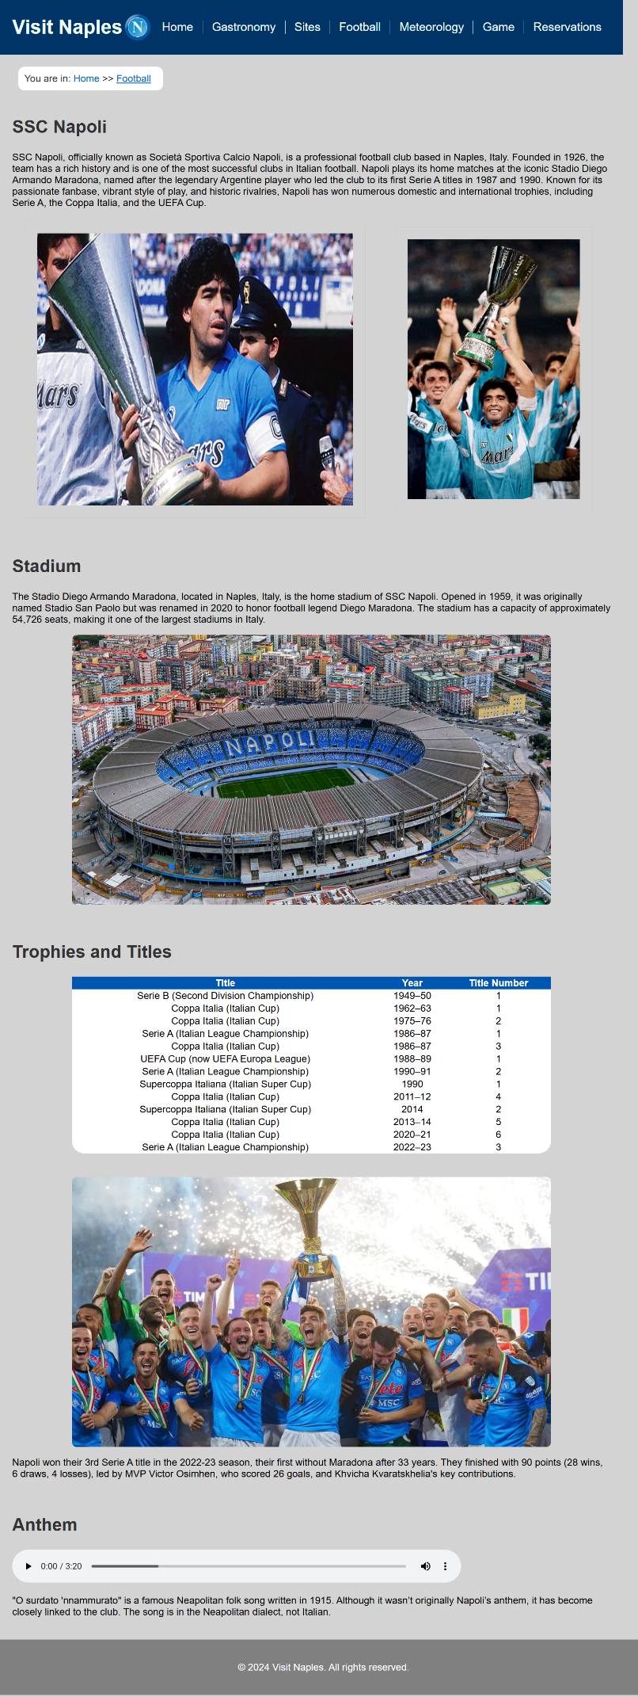

Meteorology

The Meteorology Page on Visit Naples provides users with a 5-day weather forecast for Naples, retrieved from the OpenWeatherMap API with the use of JS. It displays current weather conditions, temperatures, humidity, wind speeds, and forecasts for the upcoming days, helping visitors plan their trips accordingly. The data is fetched in real-time, ensuring accurate and up-to-date information directly from the API.

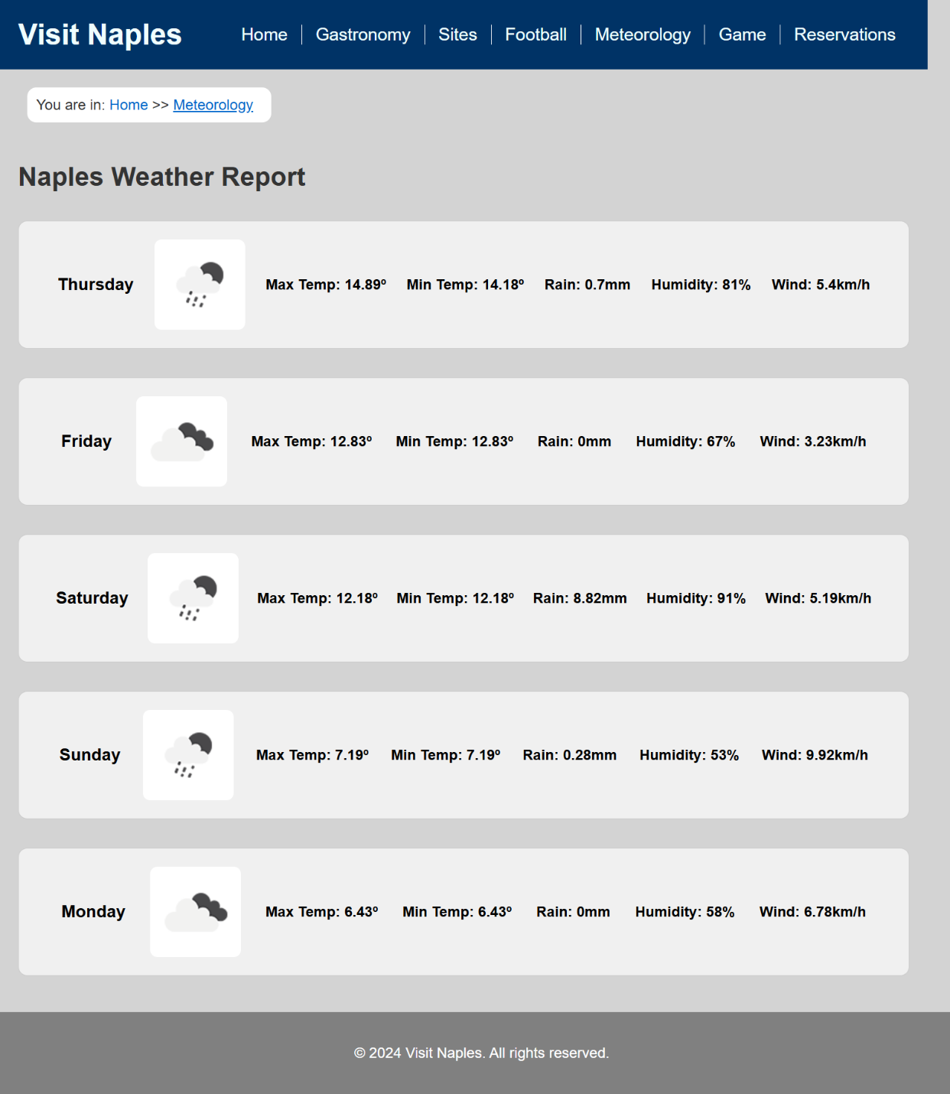

Game

The Game Page can be accessed from the Home Page or the main navigation bar. It features a fun Head or Tails game where the user can choose between "Heads" or "Tails" and flip a virtual coin. The game includes animations and keeps track of the player's wins and losses.

**Coin Imagery and Design**

The coin images used in the game pay homage to two important symbols in Naples:

1. **Heads**: The coin's heads side features a design that honours the new Federico II logo.
2. **Tails**: The coin's tails side pays tribute to the old University logo, before its change to Federico II.

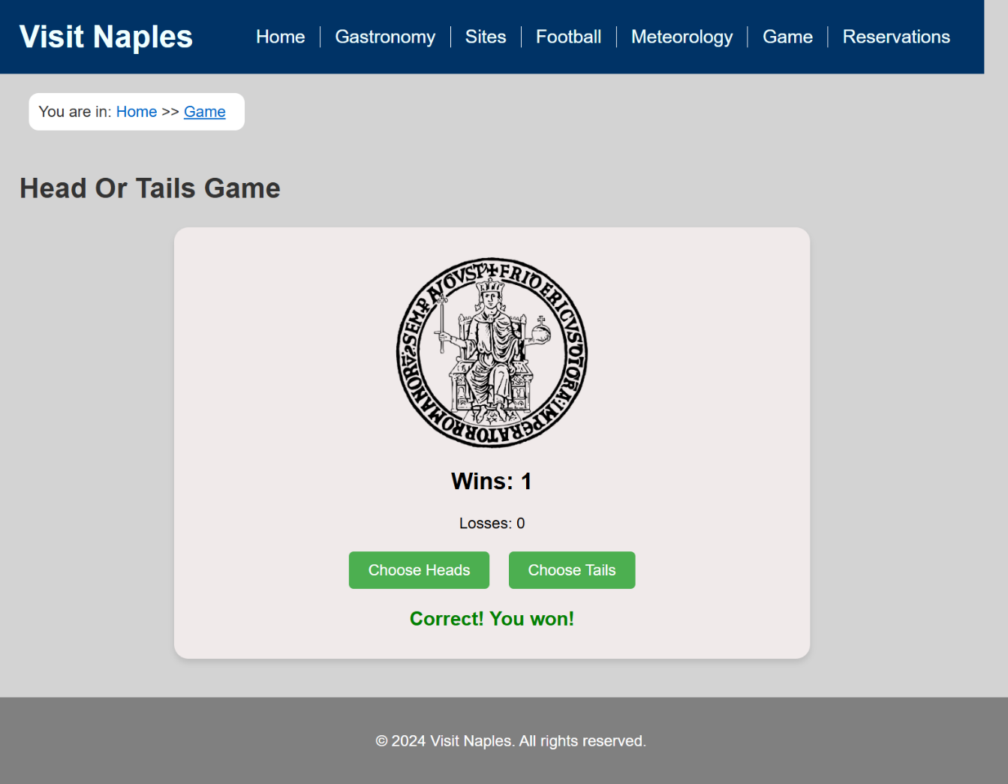

Reservations

The Reservations Page can be accessed from the Home Page or the main navigation bar. It allows users to book various activities in Naples by filling out a form that includes the following details:

• Activity selection (e.g., Pompeii, Vesuvius, Caserta Royal Palace) • Date and time preferences

• Email (for confirmation)

• Number of people

The submitted reservation data is stored in a database, and users must be registered to book any activity. If the user is not registered, they will be prompted to register before proceeding.

**Form Validation and Error Handling**

Errors are triggered if:

1. The email and repeated email do not match: Ensures the user's email is consistent across both fields.
2. An invalid email format is entered: The email must follow the correct syntax, such as:
   * Including an "@" symbol.
   * A valid domain name (e.g., example.com).
   * No spaces or invalid characters.
3. The user has already made a reservation for the selected activity at the chosen time: Conflicts with existing bookings are checked against the database.
4. Any required field is left empty: All fields must be filled out correctly to complete the reservation.

If any validation errors occur, the form will display an appropriate error message, asking users to correct the input before proceeding with the reservation. Once all details are valid, the reservation is added to the database, confirming the booking.

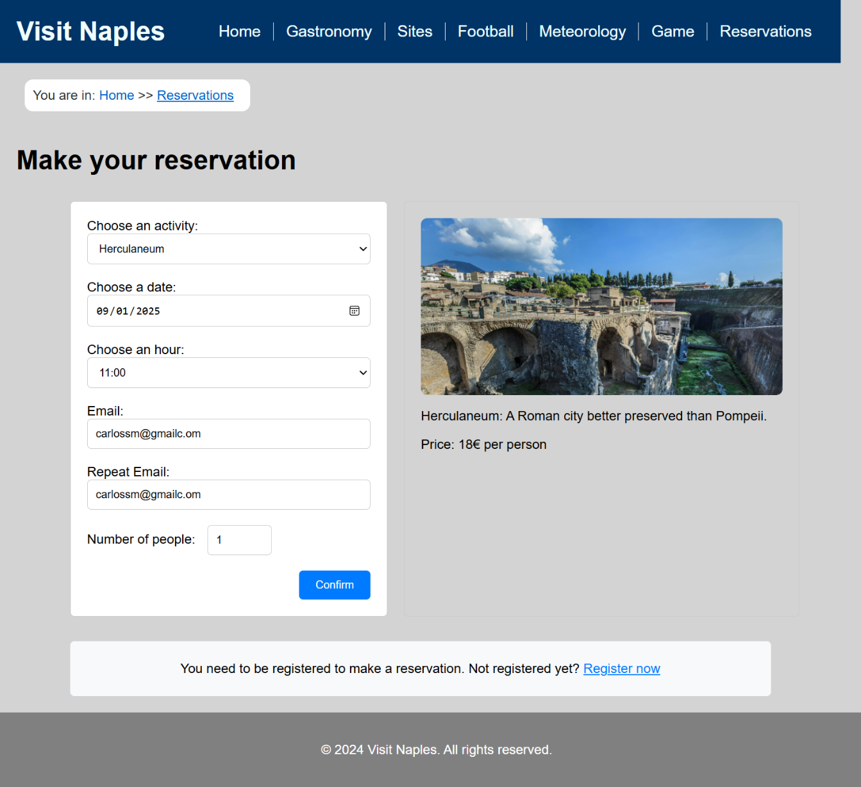

Registry

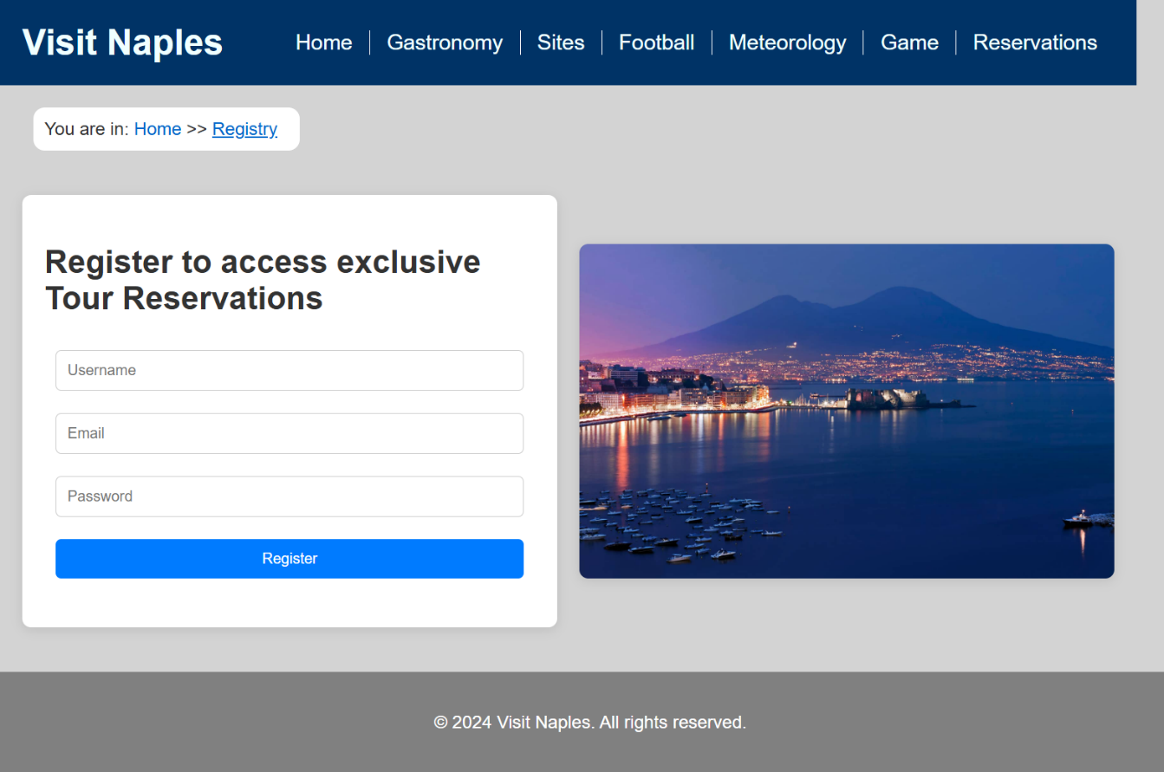

The Registry Page can be accessed from the Home Page or the Reservations Page. It features a form that collects the following user details:

* **Username**
* **Email**
* **Password**

The submitted data is stored in a database, managed using PHP. Users must be registered to make reservations, ensuring proper account validation.

**Form Validation and Error Handling**

The registry form includes error handling with JS to ensure data prevent invalid submissions. Errors are triggered if:

1. **Any field is left empty**: All fields are mandatory.
2. **The username or email already exists**: Duplicate entries are checked against the database.
3. **The email format is invalid**: The email must follow proper syntax rules, such as:
   * Including an "@" symbol.
   * A valid domain name (e.g., example.com).
   * No spaces or invalid characters.

If any validation rule is violated, the form displays an appropriate error message, prompting users to correct their input.